Multiple Choice Answers Question 1 – 10
1 C
2 D
3 C
4 B
5 C
6 A
7 B
8 D
9 D
10 B

Question 11
Latency – ping (plus response time). Measure of round-trip time between request and response.
Jitter – latency variance / delay inconsistencies. Rate at which ping changes over time.
Best effort QoS can be impacted by these factors during periods of high congestion (hardware or ISP differences aside). Results in high lag, slower app response, etc.

IP – Internet Protocol. Protocol for addressing and routing data on the internet.
TCP Transmission Control Protocol – divides files into numbered data packets, forwards them individually to the IP layer. It then waits until packets have arrived, acknowledges unreceived packets, and retransmits those that aren’t.
UDP User Datagram Protocol – like TCP but doesn’t acknowledge, resend or wait. Just keeps sending. Low latency. Good for gaming.

HTTP – Hypertext Transfer Protocol – transfers hypermedia documents. Generally used for websites.
FTP – File Transfer Protocol – transfers files.

Question 12
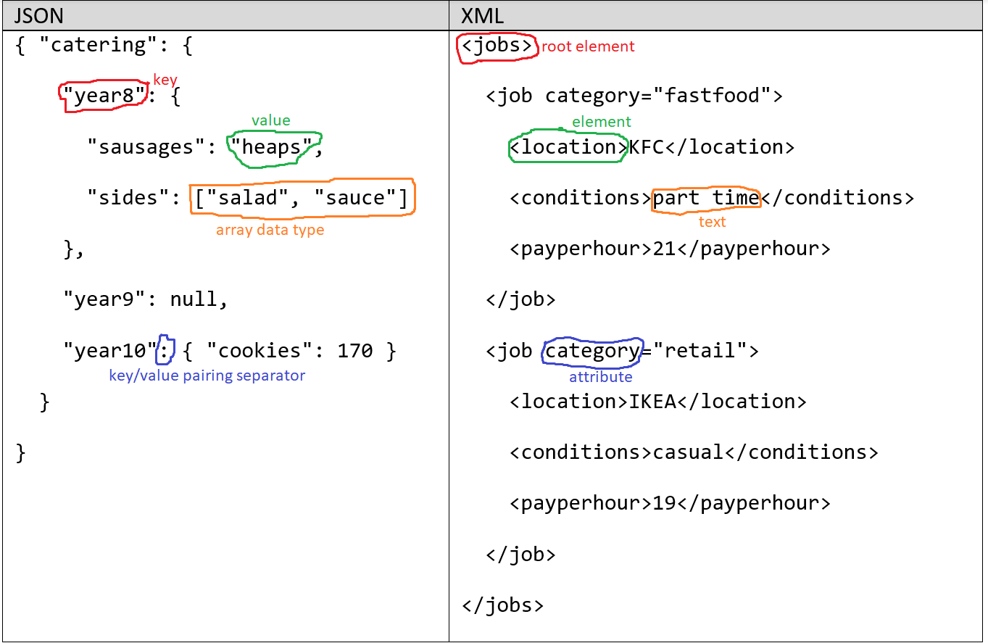

Question 13
Character (string) | Result (array values) | Valid (Boolean)
T | T | True
1 | T1 | False
2 | T12 | False
X | T12S | True
4 | T12S4 | False
5 | T12S45 | True

- Allows letters in barcode outside of character 0 (error)
- Does not return empty array if invalid (error)
- Describes Valid as True when barcode isn’t during runtime (anomaly)
- Continues to process even after invalid barcode (inefficient)
There are many methods to code a solution to this problem. Here is one attempt from a student:
BEGIN barcode scanner algorithm
SET barcode = empty array
SET processed = False
SET valid = True
SET counter = 0
WHILE NOT processed
INPUT next character in barcode sequence into variable character
IF counter == 0 THEN
IF character == "T" OR character == "S" THEN
SET barcode[counter] == character
ELSE
SET valid = False
SET processed = True
END IF
ELSE
IF digit(character) == True THEN
SET barcode[counter] == character
ELSE
SET valid = False
SET processed = True
END IF
END IF
SET counter = counter + 1
IF counter == 6 THEN
SET processed = True
END IF

END WHILE

IF valid == True THEN
RETURN barcode
ELSE
RETURN empty array
END IF
END barcode scanner algorithm

In Python, student attempted this as well, not part of the exam but FYI. Does this work? Try it:
barcode = []
processed = False
valid = True
counter = 0
while not processed:
character = input("Next char in barcode sequence: ")
if counter == 0:
if character.upper() in ["T","S"]:
barcode.append(character)
else:
valid = False
processed = True

else:
if character.isdigit():
barcode.append(character)
else:
valid = False
processed = True

counter = counter + 1
if counter == 6:
processed = True

print("valid: ", valid)
Question 14
Join condition was problem:
SELECT SUM(retailPrice * quantity) AS Profit
FROM ( Pricing JOIN Orders
ON Pricing.juice == Orders.juice)
JOIN Updates
ON Orders.orderNum == Updates.orderNum
WHERE status == "complete"

Without selling any juices with chia seed in them:
SELECT SUM(retailPrice * quantity) AS Profit
FROM ( Pricing JOIN Orders
ON Pricing.juice == Orders.juice)
JOIN Updates
ON Orders.orderNum == Updates.orderNum
WHERE status == "complete" AND Orders.juice NOT IN (
SELECT juice
FROM Recipes
WHERE ingredient == "Chia"
)

Question 15
Taken straight from class notes:
BEGIN Vigenère
VARIABLE counter = 0
INPUT plaintext as Array
INPUT key1 as Array
key1 = KEYWRAP(plaintext, key1)
VARIABLE ciphertext = []
WHILE counter < length(plaintext)
base = BASE26(plaintext[counter])
key = BASE26(key1[counter])
shift = (base + key) mod 26
ciphertext[counter] = UNICODE_CHARACTER(shift)
counter = counter + 1
END WHILE
END Vigenère

BEGIN KEYWRAP(plaintext, key):
index = 0
counter = length(key)
WHILE counter < length(plaintext)
value = key[index]
key[counter] = value
IF index < length(key) THEN
index = index + 1
ELSE
index = 0
END IF
counter = counter + 1
END WHILE
RETURN key
END KEYWRAP

BEGIN BASE26(Unicode char)
RETURN ordinal(char) – ordinal("A")
END BASE26

BEGIN UNICODE_CHARACTER(Base26 integer)
RETURN character(integer + ordinal("A"))
END UNICODE_CHARACTER

Question 16
Pseudocode for Luhn:
BEGIN luhn
INPUT card numbers INTO card_array
REVERSE card_array
SET sum TO 0
SET counter TO 0
WHILE counter < LENGTH(card_array)
IF counter MOD 2 <> 0 THEN
SET double = card_array[counter] * 2
IF double > 9 THEN
SPLIT double INTO digit1 AND digit2
SET sum = sum + digit1 + digit2
ELSE
SET sum = sum + double
END IF
ELSE
SET sum = sum + card_array[counter]
END IF
SET counter = counter + 1
END WHILE

IF card_sum % 10 == 0 THEN
OUTPUT "VALID"
ELSE
OUTPUT "INVALID"
END IF
END luhn

In Python, not part of the exam but FYI:
card = input("number: ")
card_array = [int(char) for char in str(card)]
card_array.reverse()
card_sum = 0
for index, number in enumerate(card_array):
if index % 2 != 0:
double = number * 2
if double > 9:
split = [int(char) for char in str(double)]
card_sum += split[0] + split[1]
else:
card_sum += double
else:
card_sum += number

if card_sum % 10 == 0 and card != "0":
print("VALID")
else:
print("INVALID")

Online transaction safety and security, answer could include:
- TLS (the new SSL) – encrypts data sent using asymmetric encryption RSA (very strong). Server should redirect all traffic through HTTPS.
- Hashing (min SHA512) with a salt of passwords that require session login.
- Encryption of any stored credit cards server-side must be strong – AES 128 or higher (preferably AES 256)
- Other procedures client and server-side could be mentioned (clear cache / don’t store passwords client-side, server-side security audits / vulnerability testing, etc.)

